5pts, 10 pts, 20pts, 30pts

**Bonus 5 points (can only be answered once by a single team) 😊**

C_1: What programming concepts were introduced in the first **Level 1** session? Ans: Sequential, Selection and Loops

C_2: What programming language was used to program Bot Marley? Ans: Python

C_3: Going back in time, what are some of the history of programming languages? Ans: any decent answer is fine.

* **Around 1960**, Algol 60 was created and was popular in academic circles.
* COBOL was used for data processing, and Fortran for scientific work.
* **In the UK**, Algol 60 was extended to CPL (Combined Programming Language) and then simplified to BCPL (Basic CPL).
* At Bell Laboratories in the **USA**, BCPL was transformed into B, and then into C around 1970.
* C was used to write the UNIX operating system and later **LINUX** by Linus Torvalds.
* **Around 1980**, C++ was created by Bjarne Stroustrup at Bell Labs, enabling object-oriented programming.
* **In 1995**, Sun Microsystems produced Java, which was simpler than C++ and could run on many types of computers.
* **In 2002**, Microsoft introduced C#, which was similar to C++ and Java, with enhancements, as part of the .NET initiative.

C_4: What are the different functions Buddy demonstrated in level 5. Ans: object recognition, facial recognition, speech interaction and gesture recognition

C_5: What are the main features of .NET version you chose for creating C# projects in Visual Studio? Ans: any of the answers below

The main features of .NET for creating C# projects in Visual Studio are:

* **Languages**: You can use C#, Visual Basic, and C++.
* **Website Tools**: It helps you make interactive websites, like those used for online shopping. Microsoft thinks the Internet is very important, which is why it's called .NET.
* **Cross-Platform**: .NET might be available for other operating systems, not just Windows.
* **Building Blocks**: You can create software using pieces (called 'objects') that can work together over a network.

C_6: What page in the **level 5** manual is the AI in music and AI memory on? Ans: 9 and 17

C_7: What is the answer to this >> a = "Hello, World!" >> print(len(a))? Ans

: 13

C_8: How to rewrite your code of C_32 so that the intrepeter can understand that you are extending a list using Python programming to do the same function? Write a line of code in Python to store the string “lemon” as the second item in fruits list.fruits = [“apple”, “banana”, “cherry”] Hint: extending a list Ans: fruits[1] = “lemon” ->bonus point vs Ans: fruits.insert(1, “lemon”)

**10 points**

C_9 Going back in time, what are some of the history of computer? Ans: any decent answer is fine.

* **Early 19th century**: Charles Babbage designs the **Analytical Engine**, a steam-powered mechanical computer.
* **1837**: Ada Lovelace writes the first computer program for Babbage's Analytical Engine.
* **1890**: Herman Hollerith invents the **punch card system** to process data for the U.S. Census.
* **1936**: Alan Turing introduces the concept of the **Turing machine**, a theoretical model for computers.
* **1940s**: John Mauchly and J. Presper Eckert develop the **ENIAC**, the first general-purpose electronic computer.
* **1940s**: Mauchly and Eckert also create the **UNIVAC**, the first commercially available computer.
* **1947**: Invention of the **transistor**, leading to smaller, faster computers.
* **1953**: Grace Hopper invents **COBOL**, one of the earliest high-level programming languages.
* **1958**: Creation of the **integrated circuit**, further miniaturizing computer components.
* **1969**: Ken Thompson and Dennis Ritchie develop the **UNIX** operating system.
* **1970**: Introduction of the **Datapoint 2200**, considered one of the first personal computers.
* **1971**: Introduction of the **microprocessor**, paving the way for personal computers.
* **1973**: Xerox introduces the **Xerox Alto**, the first computer with a graphical user interface.
* **1970s-1980s**: Rise of **personal computers** like the Apple II and IBM PC.
* **1975**: Microsoft is founded by Bill Gates and Paul Allen.
* **1976**: Apple is founded by Steve Jobs, Steve Wozniak, and Ronald Wayne.
* **1981**: IBM releases its first personal computer, the IBM PC.
* **1989**: Tim Berners-Lee invents the **World Wide Web**, revolutionizing information sharing.
* **2000s**: Continued advancements in computer technology, including the development of **smartphones**.

C_10 Going back in time, what are some of the history of AI? Ans: any decent answer is fine.

* 1940: invention of the programmable digital computer, a machine based on abstract mathematical reasoning. This inspired scientists to begin discussing the possibility of building an electronic brain.
* 1954: The term "Artificial Intelligence" is coined by John McCarthy at the Dartmouth Conference.
* 1956: The first AI program, Logic Theorist, is created by Allen Newell and Herbert Simon.
* 1965: Joseph Weizenbaum develops ELIZA, an early natural language processing program.
* 1972: The first expert system, DENDRAL, is developed for chemical analysis.
* 1980: The first National Conference on Artificial Intelligence is held.
* **1984: AI winter which is a period of reduced funding and interest in AI research**.
* 1986: The resurgence of neural networks with the introduction of backpropagation.
* **1997: IBM's Deep Blue defeats world chess champion Garry Kasparov**.
* 2000s: Development of machine learning algorithms and big data analytics.
* 2011: IBM's Watson wins on Jeopardy! against human champions.
* **2012: Google's DeepMind develops the AI system that learns to play Atari games.**
* 2014: Chatbots and virtual assistants like Siri and Alexa become popular.
* 2016: Google's AlphaGo defeats a human Go champion.
* 2018: OpenAI releases GPT-2, a large language model.
* 2020: AI models like GPT-3 and BERT are introduced, improving natural language processing.
* 2022: AI ethics and regulations become a major focus.
* 2023: Generative AI models like ChatGPT-4 are released, showcasing advanced capabilities.
* 2024-2025: Continued advancements in AI technology and applications. To mention iFlytek – teleport version of self which supports 60 languages, Fireflies.ai, Steven AI, a simple AI tool to help tailor your CV to the jobs you’re applying for. Video 20/08 3xbig companies leverage the utilisation of ChatGPT for use case avatar NLP, ITS, law firm like LawVu.

C_11 Who knows about AI winters? Ans: There were two major “winters” approx.... 1974-1980 and 1987-2000, we noticed this by the trend starting with pessimism in the AI community, followed by pessimism in the press, followed by a severe cutback in funding, followed by the end of serious research. Some years later the billion-dollar AI industry began to collapse and a few who makes the cut, survived the AI winters.

A period of Disillusionment

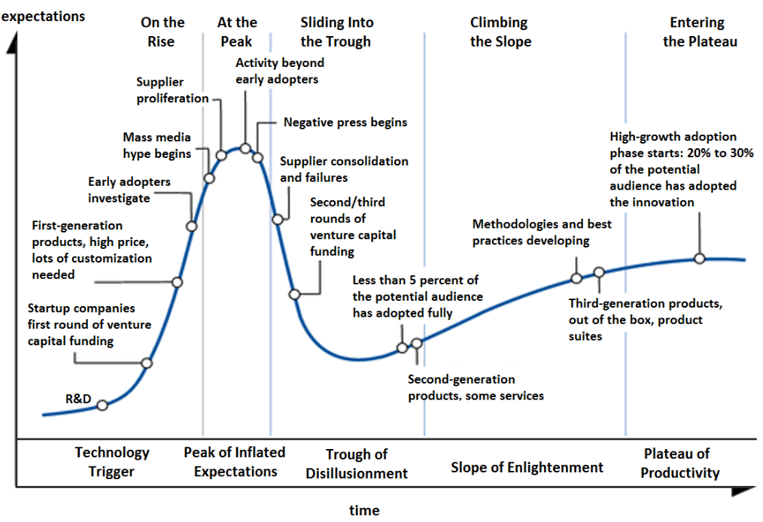

1966: failure of machine translation

1969: criticism of perceptrons (early, single-layer artificial neural networks)

1971–75: DARPA's frustration with the Speech Understanding Research program at Carnegie Mellon University

1973: large decrease in AI research in the United Kingdom in response to the Lighthill report

1973–74: DARPA's cutbacks to academic AI research in general

1987: collapse of the LISP machine market

1988: cancellation of new spending on AI by the Strategic Computing Initiative

1990s: many expert systems were abandoned

1990s: end of the Fifth Generation computer project's original goals

Enthusiasm and optimism about AI has generally increased since its low point in the early 1990s. Beginning about 2012, interest in artificial intelligence (and especially the sub-field of machine learning) from the research and corporate communities led to a dramatic increase in funding and investment, leading to the current (as of 2024) AI boom.

Now is a good time to be involved with AI work, in 30 years’ time personally predicted where it will reach all time high, before there is pessimism in the press.

C_12 Evaluate this truth table for this expression?

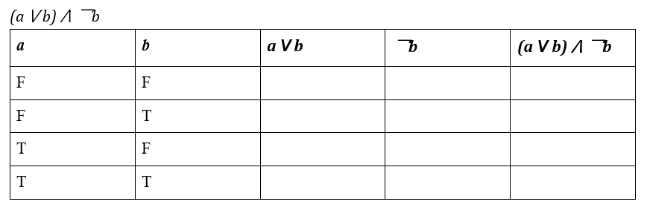

C_13: What is 01 + 01 + 01 in binary? Ans: 3 (or 0011)

C_14: What is the truth table of AND for variable a and b (a^b)? Ans:

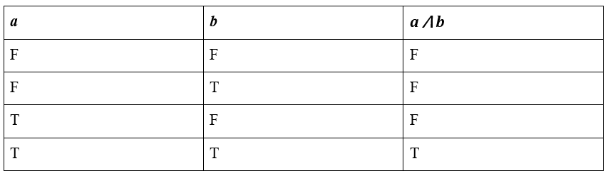

C_15: What does the import statement do in Python? Ans: used to include external modules or packages in your code

C_16: What does the function len()do in Python? Ans: to get the length of a string

**20 points**

C_17: What is the difference between a scripting language and a programming language? (explain in your own words). Ans: difference in how they're executed (interpretation vs compilation)

C_18: What are the three fundamental aspects that set Python apart from other programming languages?

Ans:

1. **Indentation matters** – Stay consistent, or Python won’t play nice.
2. **Comment your way** – Use one of Python’s three simple ways to add comments.
3. **Variables on the fly** – Just assign a value, and boom, it’s created (perfect for rapid prototyping).

C_19: What does the void keyword mean and how would you use it in C#? Ans: it is used when declaring a function (in the definition) and means it doesn't return anything

C_20: What are 3 access modifiers used in C#? Ans: can be any 3, most likely to be public, private, protected, also have others like internal etc.

C_21: How does the line following sensors on the Maqueen robots work? Ans: they emit an infrared light which will reflect off a light surface or will be absorbed by a dark one which is how they differentiate a line from a surface

C_22: What does the static keyword in C# mean? Ans: class doesn't have to be instantiated in order to access properties/methods

C_23: What does the built-in method append()have the ability to do in your code? Ans: adds an element at the end of the list

C_24 What is missing here?

**07** object_val = res [“data”][“recognition”][“name”]

**08** if object_val != “none”

**09** print(“The result of recognition is:”)

**10** print(object_val)

**11** else

**12** print(“No object found”)

Ans: : to be placed after “none” and “else”

**30 points**

C_31: How is commenting on Python differ to commenting on C#? Ans: # in Python whereas // in C#

C_32: Write a line of code to store the string “lemon” as the second item in fruits list.fruits = [“apple”, “banana”, “cherry”] Ans: fruits[1] = “lemon” ->bonus point

C_33: Explain the code as follows:

 Ans: C and D are the musical notes (do and re) which are being played in quarter beat in 4/4 music sheet and half beat.

C_34: Can you list some of the Machine Learning statistical methods typically used to categorise songs to genres? Ans: Gaussian Mixture Models (GMM), Nearest Neighbour Classification, Linear Discriminant Analysis (LDA) or Support Vector Machines (SVP)

C_35: Why indentation is a big deal in Python but not in C#? Ans: In Python, indentation is an essential part of the programming language’s syntax, Python. Indentation in Python is used to indicate blocks of code, such as those in loops, conditionals, and function definitions. The level of indentation tells the interpreter which statements belong together. For example, this code will raise an Indentation Error -.-- --- ..- / -- .- -.-- / .-- .- -. - / - --- / .--. ..- - / -... .-. .- -.-. -.- . - ... / .- - / .. if True:

print("This will raise an IndentationError")

Whereas in C# indentation is mainly used for readability and organization of code.

Even without proper indentation, the C# code below will still compile and run:

if (true)

{

Console.WriteLine("This is not indented but will still work");

}

C_36: Explain the code as follows:

**01** from irobot_edu_sdk.backend.bluetooth import Bluetooth

**02**

**03** from irobot_edu_sdk.robots import event, Robot, Create3

**04**

**05** robot = Create3(Bluetooth())

**Ans:** Lines 1 and 3 import the irobot_edu_sdk library, to call Bluetooth and bringing in the right robot which is Create 3 which is required for programming the robot.

Line 1 specifically imports the Bluetooth module from irobot_edu_sdk.backend.bluetooth to enable a Bluetooth connection with the robot.

C_37: What is raspberry pi? Ans: it is like a mini computer that lives in Buddy, which runs on a Linux operating system. It supports a diverse range of I/O options, including HDMI, USB, Ethernet, and GPIO pins for advanced computing capabilities.

C_38: Explain the code here when programming Buddy

import YanAPI

**02**

**03** ip_addr = “127.0.0.1”

**04** YanAPI.yan_api_init(ip_addr)

**05**

**06** res = YanAPI.sync_do_object_recognition()

**07** print(res)

**Ans:** Line 1 imports the YanAPI module, enabling the program to use its object recognition functionality.

Line 3 defines the ip_addr variable to store Buddy’s server IP address ("127.0.0.1") for establishing a connection.

Line 4 initialises the YanAPI module using the provided IP address to enable communication.

Line 6 calls the do_object_recognition() method from YanAPI to analyze an image, with sync_ ensuring the program waits for a result.

Line 7 calls the object recognition interface to identify objects in the analyzed image.